**Written Assignment 2**

Name: HUANG Junxin Student No.: 22401601

**Problem 1 Q1**

The computational graph for a single iterates would be:

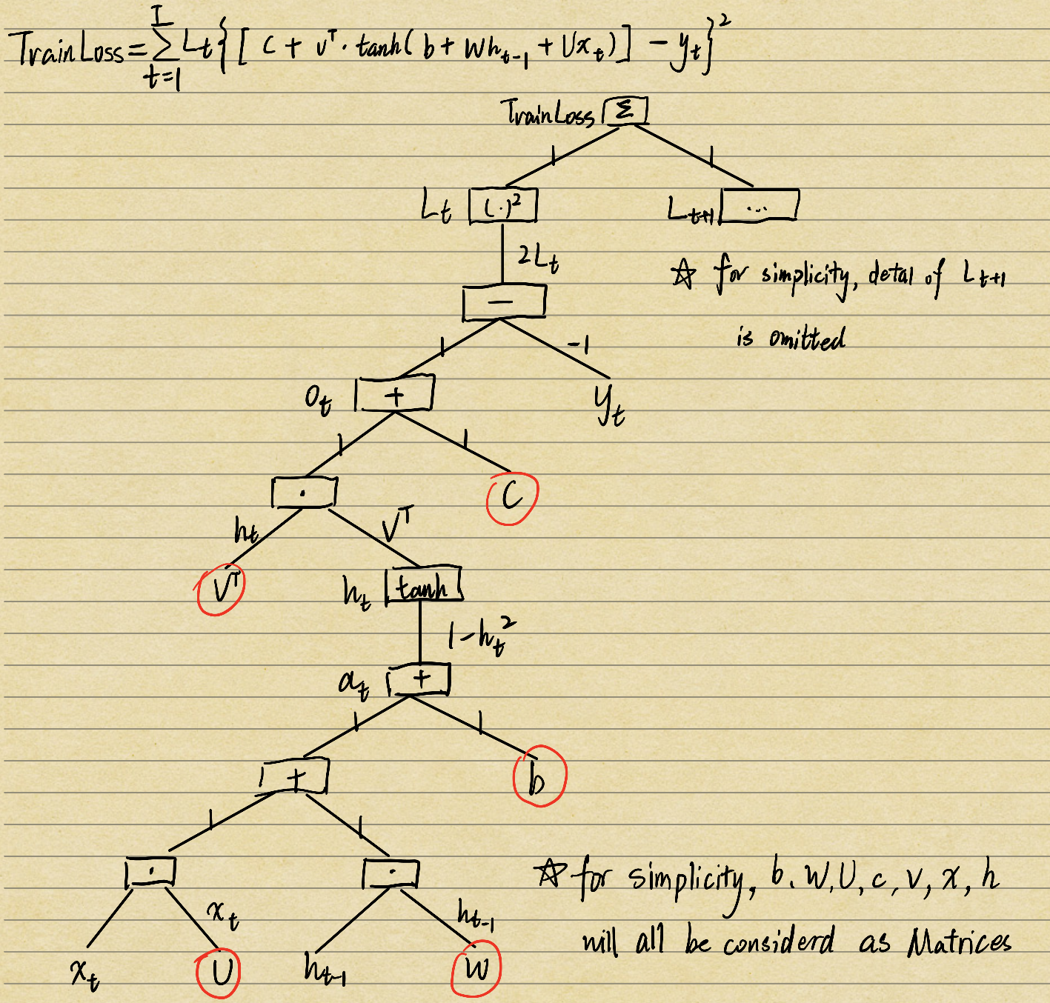

**Problem 1 Q2**

The model parameters to be learned are circled in red above.

They are: U, W, b, v, c.

**Problem 1 Q3**

The forward pass procedures are shown below:

When $t=1$,

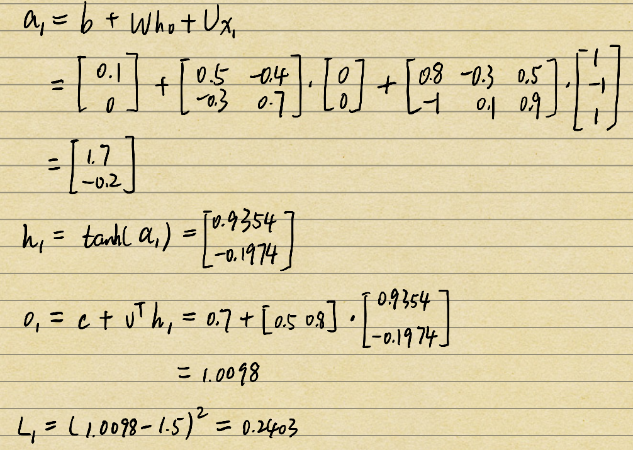

When $t=2$,

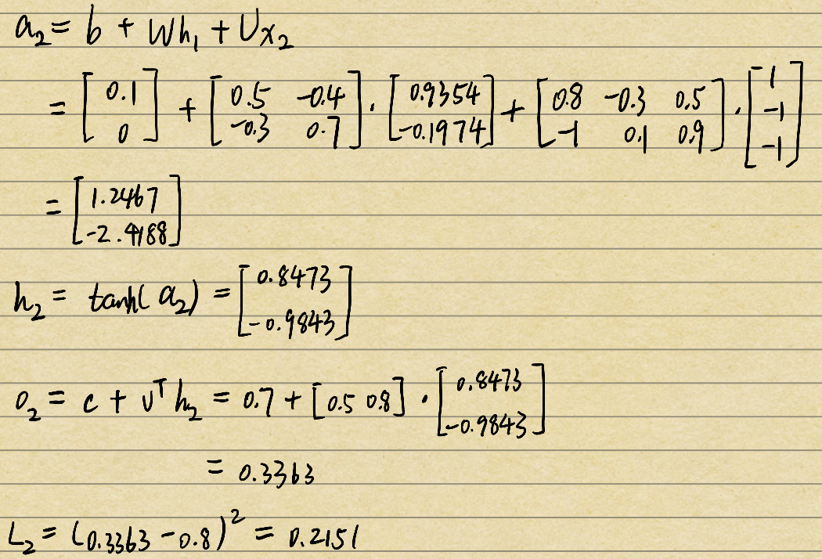

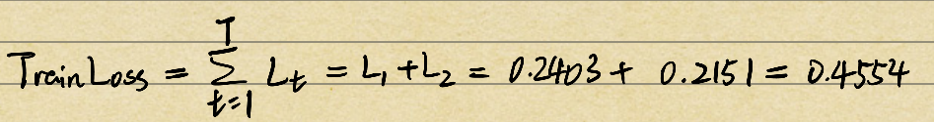

The backward pass procedures are shown below:

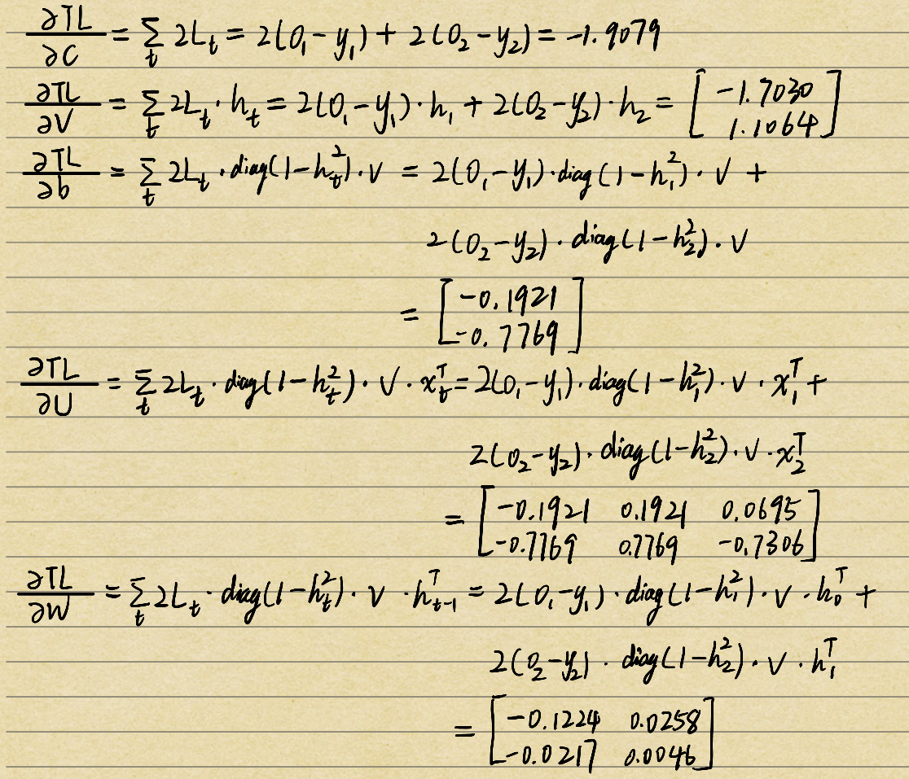

**Problem 2**

P(Yes | Green, Slightly curly, Clear, Hard)

= P(Yes) * P(Green | Yes) * P(Slightly curly | Yes) * P(Clear | Yes) * P(Hard | Yes)

= 8/17 * 3/8 * 3/8 * 7/8 * 6/8

= 0.04343

P(No | Green, Slightly curly, Clear, Hard)

= P(No) * P(Green | No) * P(Slightly curly | No) * P(Clear | No) * P(Hard | No)

= 9/17 * 3/9 * 4/9 * 2/9 * 6/9

= 0.01162

Because P(Yes | Green, Slightly curly, Clear, Hard) > P(No | Green, Slightly curly, Clear, Hard), the prediction generated by a naive Bayes classifier would be “Yes”.

**Problem 3 Q1**

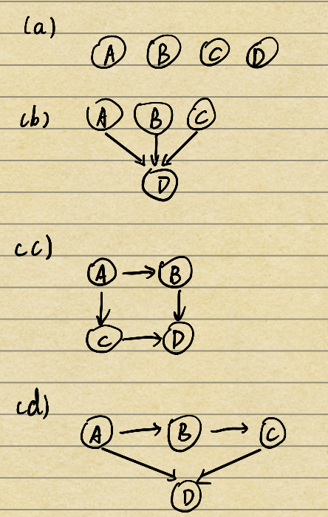

**Problem 3 Q2**

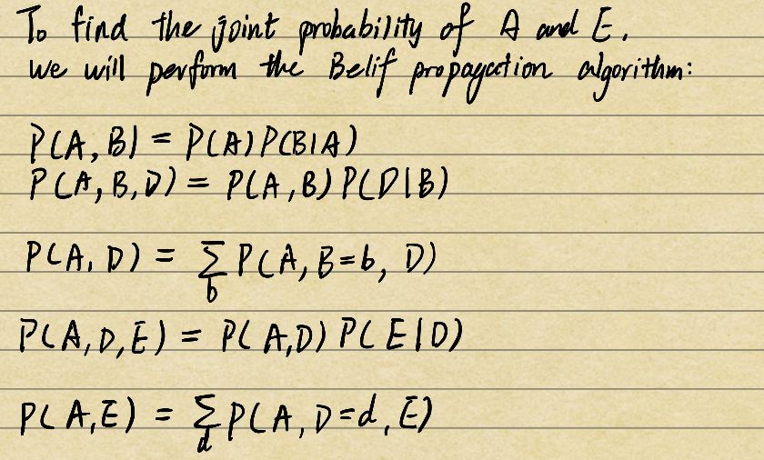

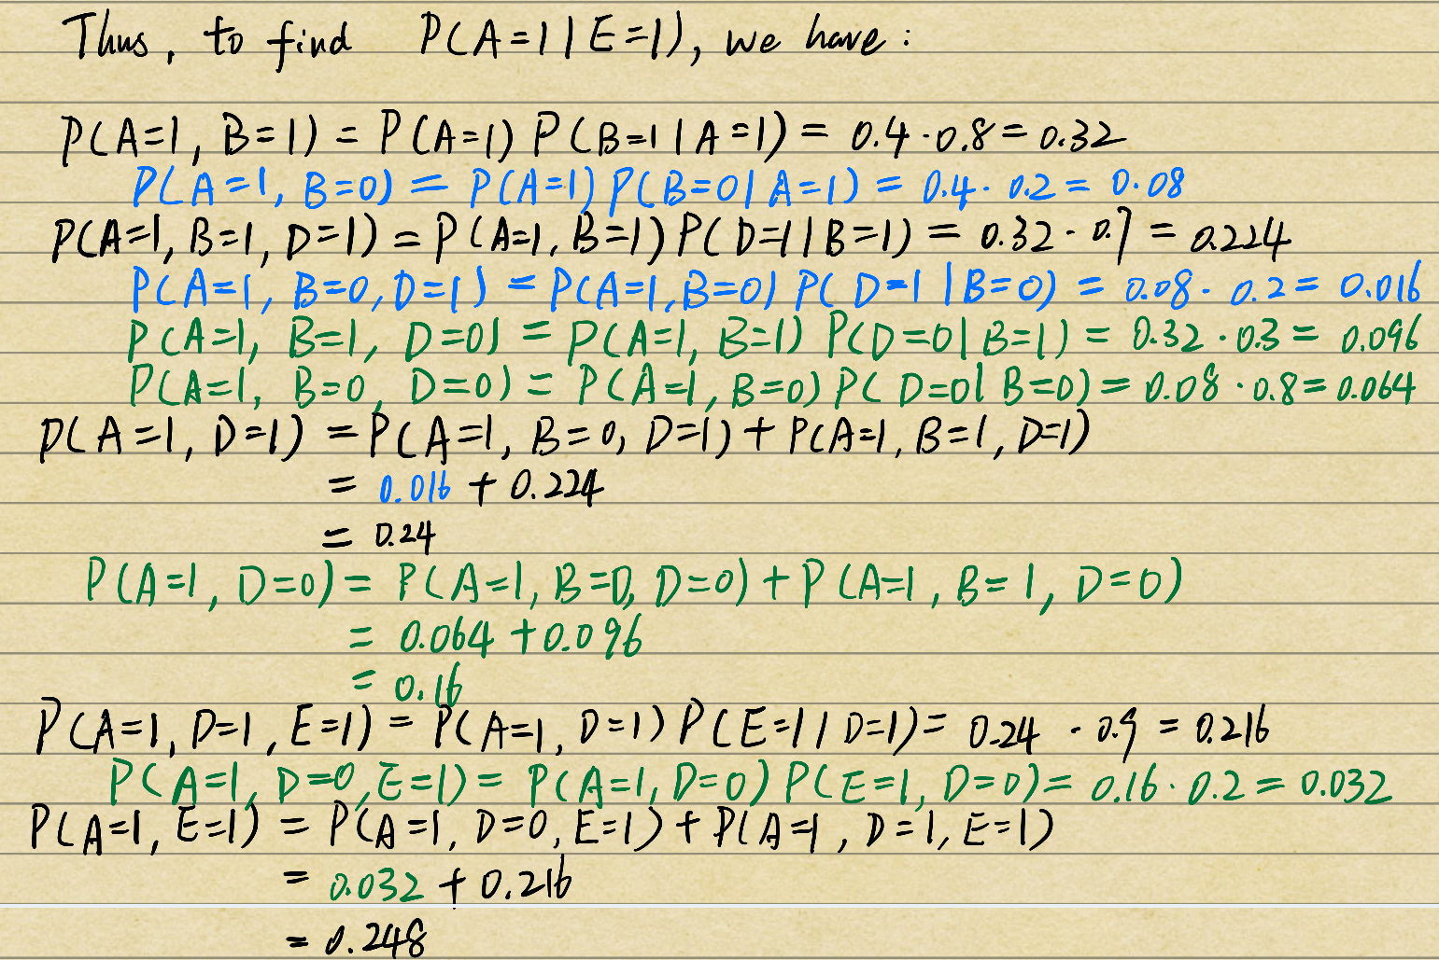

**Problem 4**

abc